Brochure
Organisation
of SPF

Organisation of SPF

SPF Mission and Vision

SPF administers SABIC’s pension scheme in the Netherlands. Within the chosen risk attitude, SPF strives for the best possible pension results for its members and ensures members are well informed and supported in their pension choices.

Both the members and social partners of the SPF fund are confident in how the pension schemes are administered. The fund itself also remains close to its members and achieves the best possible pension results. SPF responds to social changes and informs its members proactively and clearly through various means of communication.

Board
The SPF board has ten mebers. The
members are appointed by the board. Of these ten members:
a. four members are proposed by SABIC;
b. two members are proposed by the (Central)
Works Council(s) of SABIC;
c. two members are selected from and by the
pensioners;
d. the SPF board is extended by two
external management professionals.

In addition, the SPF board has an external, independent Chairman, who is appointed by the SPF board.

What does the board do?

The board must of course manage the fund. In doing so it must always strike a fair balance
between the interests of all of its stakeholders, such as members, pensioners, deferred
(members and) pensioners and the employer.

Management of the fund includes the
following tasks:

- drawing up and implementing the fund’s
articles of association and pension
regulations;
- ensuring that the accrued pension
entitlements of the members are
maintained;
- ensuring that accrued pensions are paid out
to pensioners;
- managing the risks associated with the
fund’s activities;
- determining how the fund’s assets will be
invested and investing them;
- determining how the fund should
communicate with its members and
communicating with them.
SPF’s Board members

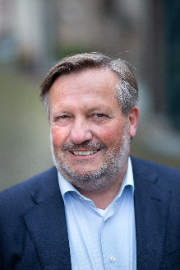
Arnout Korteweg
(Chairman)
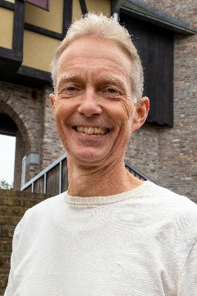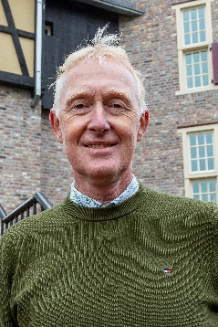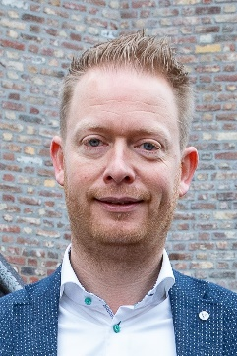
Jos van Gisbergen Vacancy John van Moorsel Maurice Pelsers

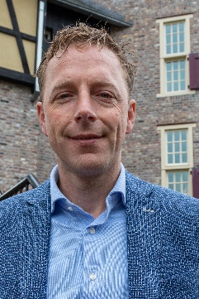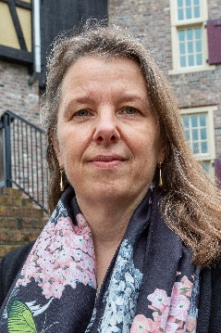
Rudger Schiewer Giselle Verwoort

(Vice Chairman)

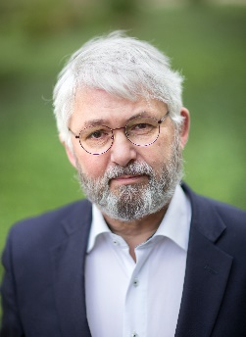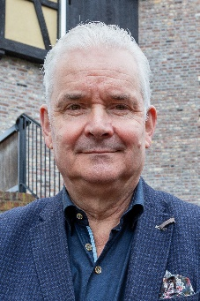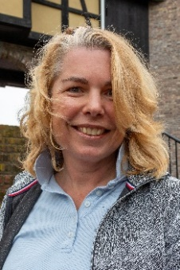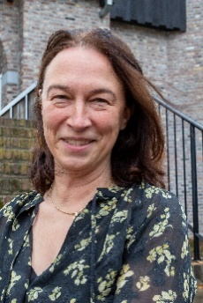
Arthur Smit Math Peeters Angela Peters Kim Haasbroek

Supervisory Board

The activities of the Board are monitored by the Supervisory Board.
The Supervisory Board comprises three experts who are independent of the pension fund. The
members of the Supervisory Board are
appointed by the Board following approval by
De Nederlandsche Bank (DNB).

What does the Supervisory Board do?

- It monitors and supervises:
  - policy;
  - adequate risk management;
  - well-balanced evaluation of interests.

- It provides advice and reports on findings to the Board.

- It jointly determines policy due to approval rights.

- It accounts for its actions to the Accountability Council (AC) and the employer.

Who are the members of the Supervisory Board?

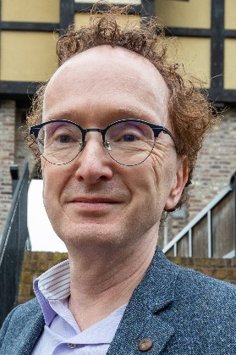
Stephan Linnenbank

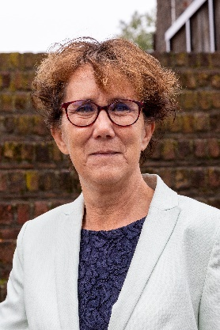
Willeke Ong

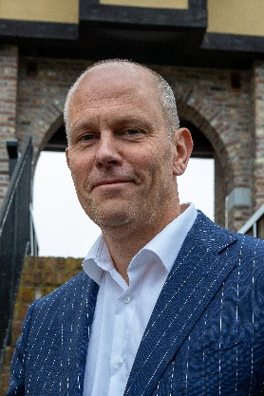
Kees Scheepens
(Chairman)

Accountability Council

The Accountability Council has six
members. Of these six members:

a. two members are appointed by SABIC;
b. two members are appointed by the participants;
c. two members are selected from and by the pensioners.

What does the Accountability
Council do?

The board must account to the Accountability Council for its policy and the way it is
conducted. The Accountability Council must
deliver an opinion on this at the end of each
year. A critical factor for the opinion is whether or not the board has represented the interests of all stakeholders fairly.

The Accountability Council also has the right to make recommendations about amongst other things:

- the policy on remuneration;
- the forms and establishment of internal
supervision;
- the draft and amendment of an internal
complaints and disputes procedure;
- the draft and amendment of the
communication and information policy;
- the transfer or take-over of liabilities by the
pension fund – in part or as a whole;
- the liquidation, merger or split-up of the
pension fund;
- the conclusion, amendment or termination
of an administrative contract;
- the amendment of the pension fund’s legal form.

Who are the members of the Accountability Council?

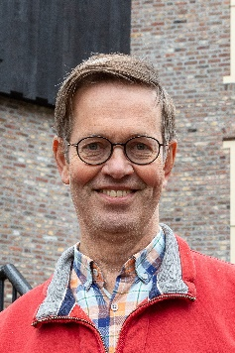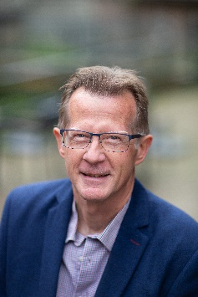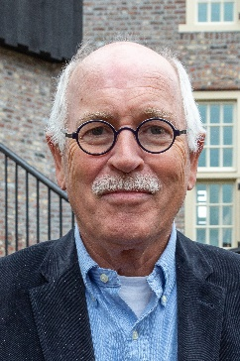
Rolf van Kouwen Herman Polderman Jan Hellings
(Chairman) (Vice Chairman)
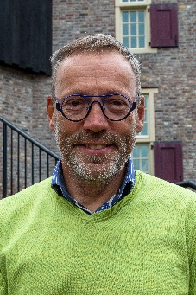
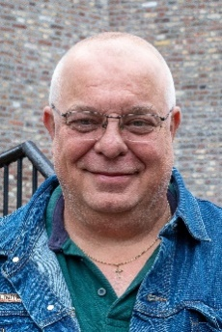

Toine Jansen René Witjes Vacancy

Board of SPF

Appointed by the employer:
Jos van Gisbergen
Vacancy
John van Moorsel
Maurice Pelsers

Proposed by the SABIC Works Council(s) (Ondernemingsraden):
Rudger Schiewer (Vice Chairman)
Giselle Verwoort

Elected from and by the pensioners:
Arthur Smit
Math Peeters

Appointed by the Board- independent Chairman:
Arnout Korteweg

Appointed by the Board – Professional Board’s members:
Angela Peters
Kim Haasbroek

Supervisory Board

Stephan Linnenbank
Willeke Ong
Kees Scheepens (Chairman)

Accountability Council

Appointed by the employer:
Toine Janssen
Rolf van Kouwen (Chairman)

Appointed by the participants:
Herman Polderman
René Witjes

Elected from and by the pensioners:
Jan Hellings (Vice Chairman)
Vacancy

Contact
If you have any questions about your pension visit the website: spf-pensioenen.nl
or contact our Pension Desk:
phone: +31 (0)45 - 5788100
or email: info.PensioenfondsSABIC@dsm.com

Disclaimer
The information provided in this brochure by Stichting Pensioenfonds SABIC, with its registered office in Sittard (the ‘pension fund’) is general, purely indicative and subject to change. It is intended only to provide members with a general overview. The information provided is assumed to be reliable, but is used entirely at the user’s risk. Neither the administrator
(DPS B.V.), nor the pension fund accepts any liability for damage arising from errors or omissions in the information, or for damage arising in connection with the use of, reliance on, or distribution of the information. Rights can be derived only from the pension regulations applying to the member.

